**Project Name** : Level Supermind APK Bug Report

**Module Name :** Bug Test

**Created By** : Waheed Husain

**Bug Id** : Bug_01

**Bug Title** : Confusion of Slider in the Beginning.

**Expected Result** : The Slider Should Represent according to its position.

**Actual Result** : The Slider showing different positions for different pages.

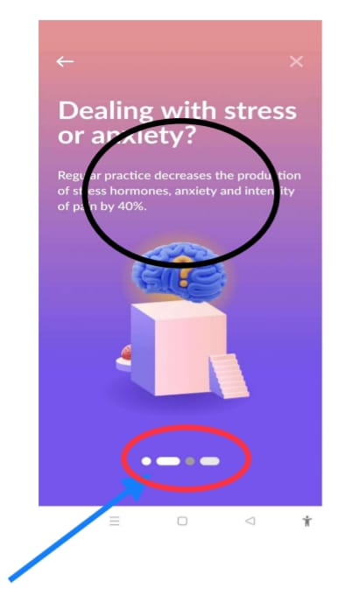

**Bug Id** : Bug_02

**Bug Title** : Font Size is Larger than the Expected size

**Expected Result** : The Better user interface with perfect font size.

**Actual Result** : Large font size than the flexible size.

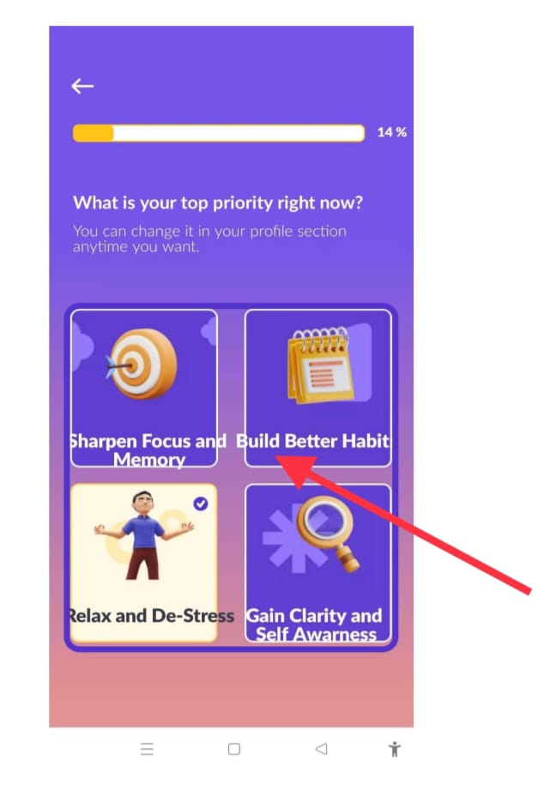

**Bug Id** : Bug_03

**Bug Title** : 100% completion is not displaying.

**Expected Result** : 100% progress should be done done.

**Actual Result** : Progress is showing 99% at top right corner.

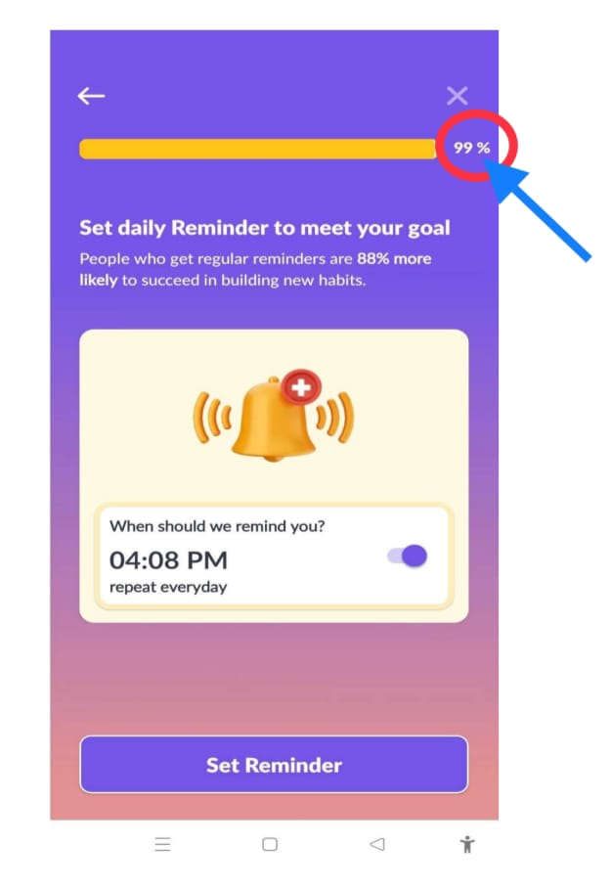

**Bug Id** : Bug_04

**Bug Title** : Audio Stop at the center point.

**Expected Result** : Audio should work properly without interruption.

**Actual Result** : Audio is stop at the middle point .

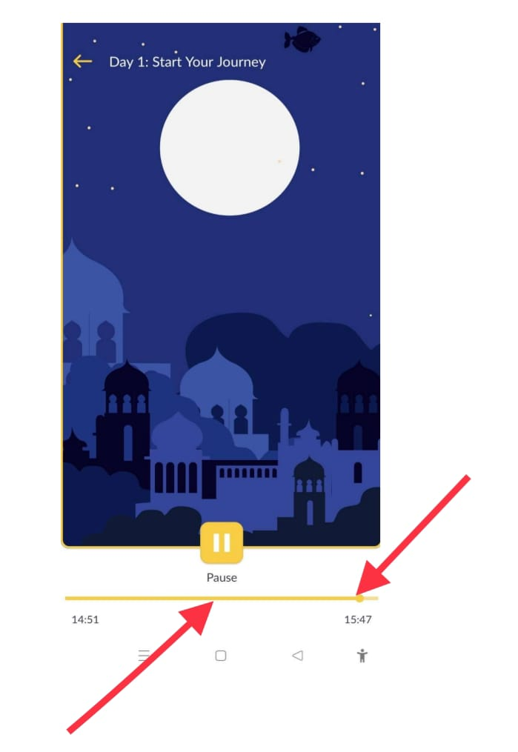

**Bug Id** : Bug_05

**Bug Title** : Readability of privacy policy term.

**Expected Result** : Privacy policy should be term should not repeat.

**Actual Result** : Privacy policy terms are same at two times.

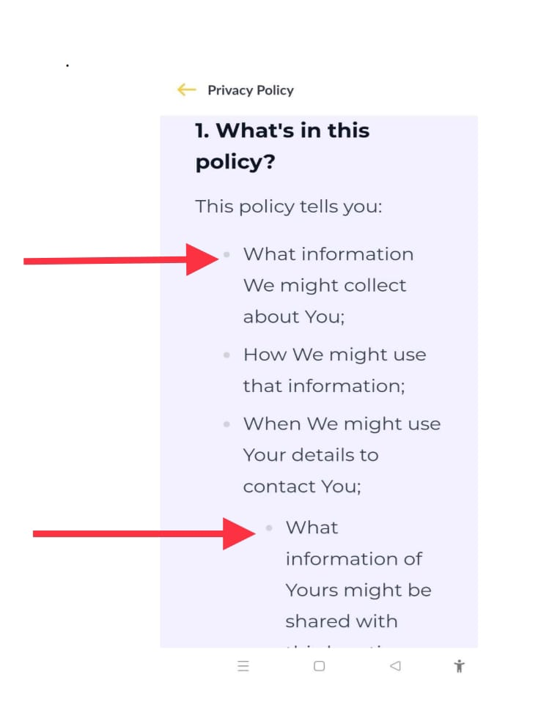

**Bug Id** : Bug_06

**Bug Title** : Forward video functionality is not working properly.

**Expected Result** : while clicking on 10 sec forward option video should skip 10 sec.

**Actual Result** : After clicking 10 sec the video skips 15 sec instead.

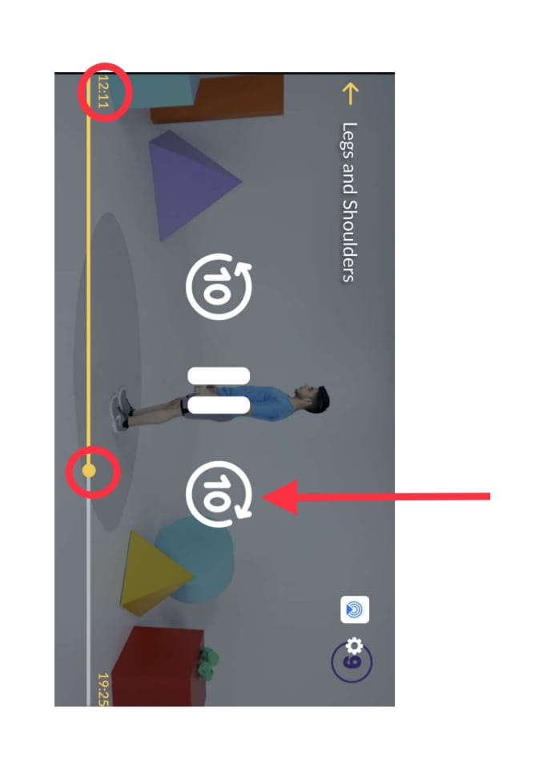

**Bug Id** : Bug_07

**Bug Title** : Backward video functionality is not working properly.

**Expected Result** : while clicking 10 sec backward option video should reverse 10 sec

**Actual Result** : click on backward 10 sec option video skip previous 5 seconds only.

